

Handout: Selenium
Version: 1.0

TABLE OF CONTENTS
Chapter 1: Introduction 4
Introduction 4
Application of Selenium 4
Capabilities of Selenium 4
Features of Selenium 4
Limitations of Selenium 5
Chapter 2: Components of Selenium 6
Components of Selenium 6
Chapter 3: Selenium IDE 7
What is Selenium IDE 7
Selenium IDE Window 7
Recording a test in IDE 8
Exporting a test from IDE 8
Features of Selenium IDE: 9
Limitations of Selenium IDE: 10
Installing Selenium IDE 10
Chapter 4: Selenium RC 11
Selenium Remote Control 11
About Selenium Remote Control 13
Installation of Selenium Remote Control 13
Steps involved in installation (Pictorial Representation) 14
IDE and Remote Control Integration. 15
Execution of a Test 16
Data Driven Approach using selenium: 16
Report Generation 17
Chapter 5: Selenium Core 18
Selenium Core 18
How does Selenium Core Work? 18
Platform and Browser Compatibility 18
Installing Selenium Core 19
Running Selenium's Test Suite – Test Runner 19
Control Panel 20
Chapter 6: Selenium Grid 22
What is Selenium Grid? 22
Why use Selenium Grid? 22
Selenium Grid Setup 23
Chapter 7: Selenium API 25
Selenium Concepts 25
Selenium Tips and Tricks 26
Chapter 8: Reference 27
Websites 27

Chapter 1: Introduction

Introduction

Selenium is an open source test automation tool for executing scenarios against web applications to validate browser compatibility and system functionality. Selenium is easy to set up and quick to develop tests for testing. These tests can be created and executed using your Firefox browser. It is powerful and easy to use.

Application of Selenium

Selenium is a great tool for functional testing of web sites. Scripts can be written as HTML tables which Selenium will process and use to drive a web browser through your application using JavaScript. Selenium tests runs directly in a browser - just like your users do! It can use IE, Mozilla and Firefox on Windows, Linux and Macintosh.
With the Firefox plug-in creating tests is as easy and clicking and selecting text. However these tests can be compiled into a format that works with Java, .NET, Perl, Python and Ruby.

Capabilities of Selenium
- Selenium IDE has the option of easy record and playback
- Selenium can be used to develop test cases to automate the testing of websites.
- Selenium can perform actions such as clicking a button, clicking a link, firing an event, entering values in text field and submitting forms.
- Save tests as HTML, Ruby scripts, or any other format
- Option to add checkpoints and assert the title of every page
- We can also set check points to check whether a text is present in the page, or existence of an object.
- Scripts can be written with reference to objects and user actions performed on the objects so that Selenium can perform those actions on the webpage.
- We can also parameterize our test using an external excel sheet with the data which can be retrieved during run time and used in the test.
- Selenium supports working with regular expressions.

Features of Selenium
- Record and Playback
- Object Spy – DOM inspector in Firefox.
- Multiple domain support
- Usage of multiple properties for object identification.
- HTTPS support in IDE and HTML scripts
- Language of scripting using Ruby, Python, Perl, Java, .NET
- Web-app independent
- Browser type independent (IE & Firefox)

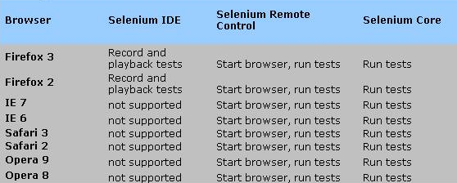

Limitations of Selenium
- Cannot playback multiple scripts simultaneously
- Has problems in handling frames and popup
- Dependent on web application – Needs to be deployed with application if we use selenium core
- HTTPS protocol is not supported by Selenium remote control.
- Does not have object repository.

Chapter 2: Components of Selenium

Components of Selenium
Selenium has four components as follows:

- Selenium IDE - Plug-in to Firefox to record and play test in "firefox"
and also export tests in different languages.
- Selenium Core
- Selenium Remote Control - Allows playing of exported test in different platform/OS
- Selenium Grid - Allows to control lots of selenium machines

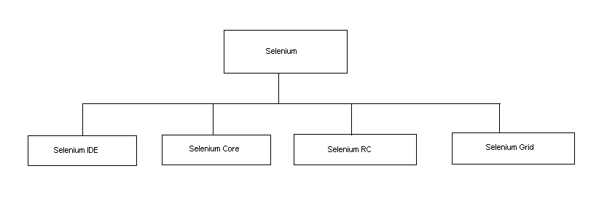

Chapter 3: Selenium IDE

What is Selenium IDE
Selenium IDE is a Firefox add-on that records clicks, typing, and other actions to make a test, which you can play back in the browser. Selenium IDE is an integrated development environment for Selenium tests. It is implemented as a Firefox extension, and allows you to record, edit, and debug tests. Selenium IDE includes the entire Selenium Core, allowing you to easily and quickly record and play back tests in the actual environment that they will run.
Selenium IDE is not only recording tool: it is a complete IDE. You can choose to use its recording capability, or you may edit your scripts by hand. With auto complete support and the ability to move commands around quickly, Selenium IDE is the ideal environment for creating Selenium tests no matter what style of tests you prefer.

Selenium IDE Window

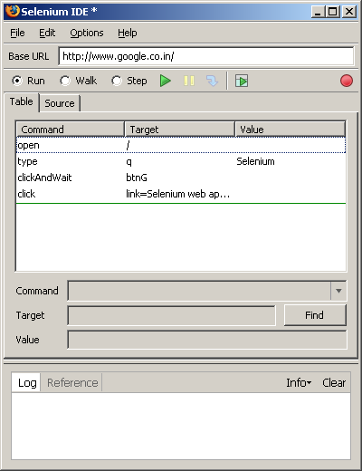

Recording a test in IDE
Step 1: Open Firefox window
Step 2: Goto Tools → Selenium IDE
(Once the Selenium IDE is clicked, it is automatically in the record mode)
Step 3: Minimize the IDE window and open any other websites in the web browser
Step 4: To stop recording click minimize button from the IDE window

Every action that is done in the firefox window, with the selenium IDE in the record mode is recorded as commands in the IDE window. Example: Clicking a button, typing a text, verifying the text present, Wait for the window to load, clicking a link etc
Selenium IDE records everything that is done. Right clicking on any object brings up the selenium IDE menu. Here some of the commands that can be used are present. As we perform the actions in our browser, simultaneously our actions get recorded in IDE window. To turn off the record mode, click the record button on IDE window. To play the test again, click the play button present in the IDE. The browser does exactly what was recorded by IDE and IDE indicates the success and failure in the IDE window itself. If there is any trouble in running the tests, we can always check that in the Log Console.

Right clicking on any command in the IDE window brings up the context menu where the breakpoint option is present. Clicking on this option, allows us to place the breakpoint on any desired command. With the breakpoint set and clicking play, the IDE stops execution when it reaches the breakpoint. Clicking the resume button runs the remaining script. This recorded script can be saved by .html format.

Exporting a test from IDE
The recorded tests can be compiled into a format that works with Java, .NET, Perl, Python and Ruby by the following steps:

Go to File →Export Test As →(Select the format to which the test is to be exported)
Below is the screen shot of the steps to be followed.

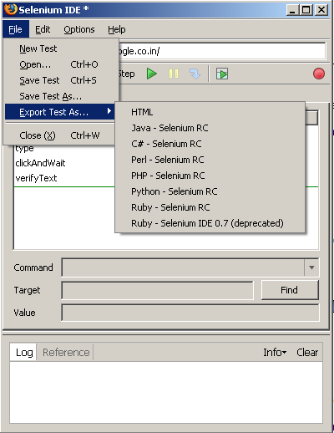

Features of Selenium IDE:
- Easy record and playback
- Intelligent field selection will use IDs, names, or XPath as needed
- Auto complete for all common Selenium commands
- Walk through tests
- Debug and set breakpoints
- Save tests as HTML, Ruby scripts, Java, c#, Perl and Python
- Support for Selenium user-extensions.js file
- Option to automatically assert the title of every page

Limitations of Selenium IDE:
- Cannot execute multiple Scripts
- Scripts cannot be grouped as suites.

Installing Selenium IDE

Follow the below steps for installation
1. Install Mozilla Firefox/2.0.0.5 browser
2. Download Selenium IDE0.8.7 from the URL: http://www.openqa.org/selenium-ide
3. Open the Mozilla Firefox browser
4. On the browser click on File → Open File →selenium-ide-0.8.7(open the XPI file)
5. Restart Firefox
6. Go to tools option in the browser and click on Selenium IDE and the tool gets invoked

Chapter 4: Selenium RC

Selenium Remote Control
Selenium Remote Control (RC) is a test tool that allows you to write automated web application UI tests in any programming language against any HTTP website using any mainstream JavaScript-enabled browser.
Selenium RC comes in two parts.
- A server which automatically launches and kills browsers, and acts as a HTTP proxy for web requests from them.
- Client libraries for your favorite computer language.
The RC server also bundles Selenium Core, and automatically loads it into the browser.
Here is a simplified architectural representation....
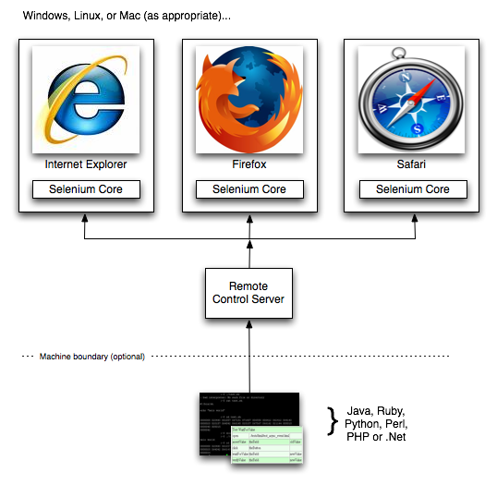
The Selenium Server is great for testing complex AJAX-based web user interfaces under a Continuous Integration system. It is also an ideal solution for users of Selenium Core or Selenium IDE who want to write tests in a more expressive programming language than the Selenese HTML table format customarily used with Selenium Core.

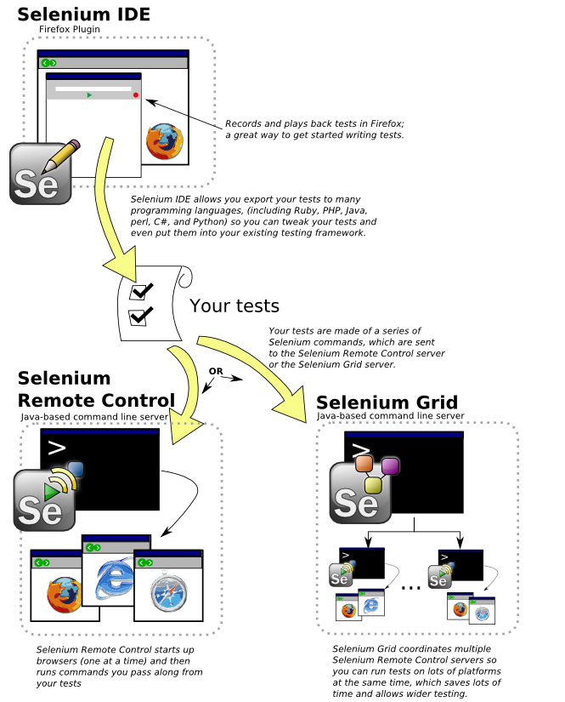

About Selenium Remote Control
Selenium Remote Control provides a Selenium Server, which can automatically start/stop/control any supported browser. It works by using Selenium Core, a pure-HTML+JS library that performs automated tasks in JavaScript.
The Selenium Server communicates directly with the browser using AJAX (XmlHttpRequest). You can send commands directly to the Server using simple HTTP GET/POST requests; that means that you can use any programming language that can make HTTP requests to automate Selenium tests on the browser. To further ease this process, we provide wrapper objects for a number of mainstream programming languages (Java, .NET, Perl, Python, and Ruby).
Finally, the Selenium Server acts as a client-configured HTTP proxy, to stand in between the browser and your website. This allows a Selenium-enabled browser to run JavaScript on arbitrary websites.
The Selenium Server is great for testing complex AJAX-based web user interfaces under a Continuous Integration system. It is also an ideal solution for users of Selenium Core or Selenium IDE who want to write tests in a more expressive programming language than the Selenese HTML table format customarily used with Selenium Core.

Installation of Selenium Remote Control

- Install Ruby (Any other software’s like Java, .Net, Perl, Python but it is advisable to use ruby) in the respective machines. Please refer the link below for installation :
http://rubyforge.org/frs/?group_id=167

Execute the file “ruby186-25”
- Download the following folder(selenium-remote-control-0.9.0) in the hyperlink below to your machine :
http://selenium-rc.openqa.org/download.html
- Now setting up the Selenium server available at the following path below

http://www.softpedia.com/get/Internet/Servers/Server-Tools/Selenium-Server.shtml

Right click on the c (Batch file) and click edit and update your proxy setting as per your internet explorer options available at “Tools >> Internet Options >>Connections >>LAN settings

- Now record the functionality using selenium IDE , to use selenium IDE refer above about Selenium IDE

- The recorded scripts can be saved in ruby format using .rb extension

- Now start the selenium server and execute the saved .rb file by opening it and clicking on Tools>>Go to view the error also open view >> output

Steps involved in installation (Pictorial Representation)
a.) Execute the ruby186-25 and install ruby
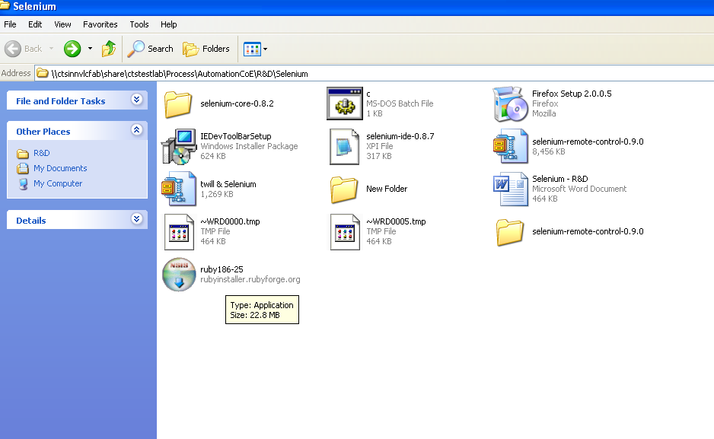
b) Now edit the batch file with the proxy settings and execute the batch file.

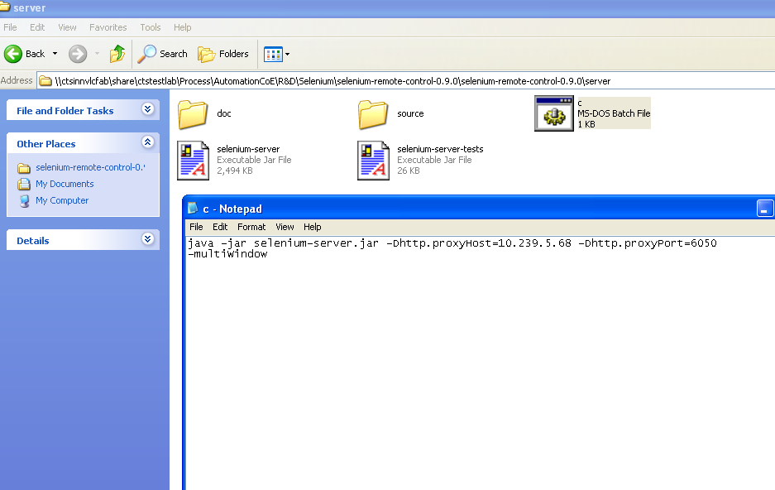

c)Now execute the .rb file.

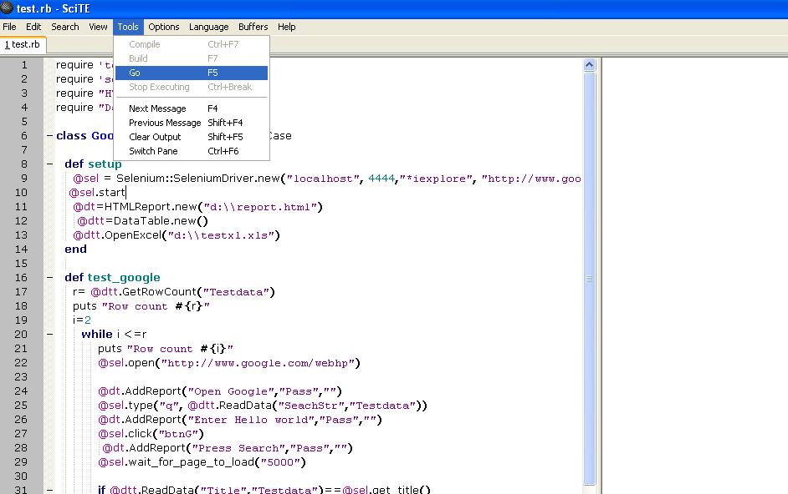

IDE and Remote Control Integration.
Now the scripts recorded can be converted to ruby as shown below and then start the selenium server and execute the .rb file. So IDE servers as main source

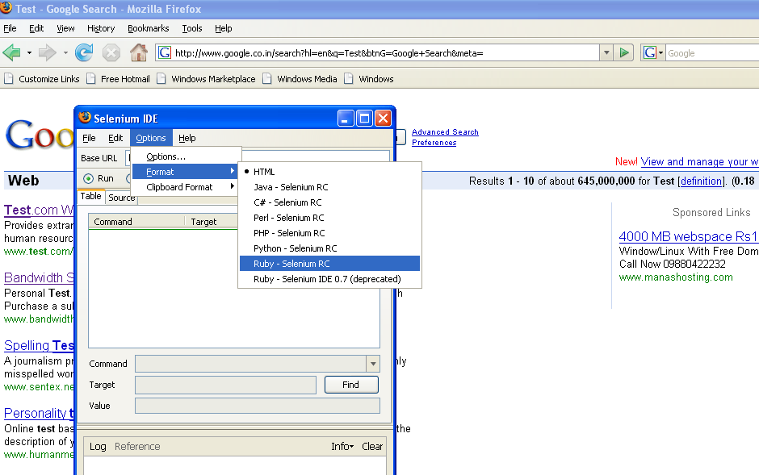

Execution of a Test
The recorded scripts can be played back by clicking Tools >> Go available on
menu as shown below. The browser gets opened and execution takes place as per the test steps.

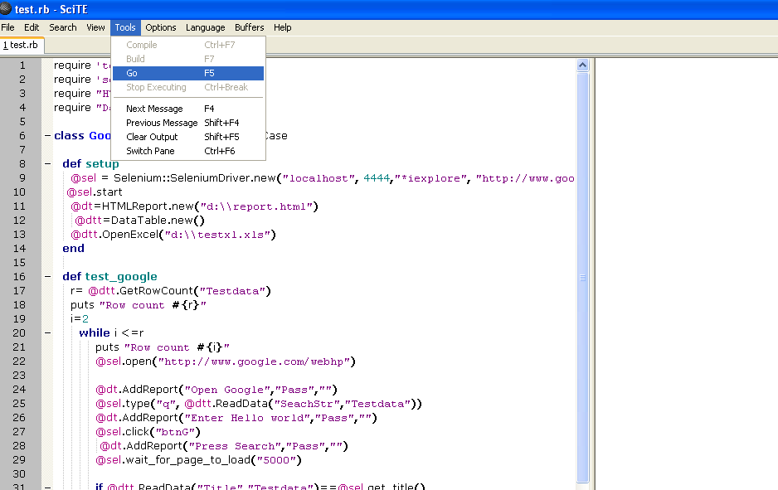

Data Driven Approach using selenium:
Data-driven testing allows you to test with different set of input values to be sure that the application works as expected, scripts read data from an external storage site, for example, from a file rather than use values hard-coded in the script and this is made possible by selenium. Please note that the recorded scripts need to be parameterized.
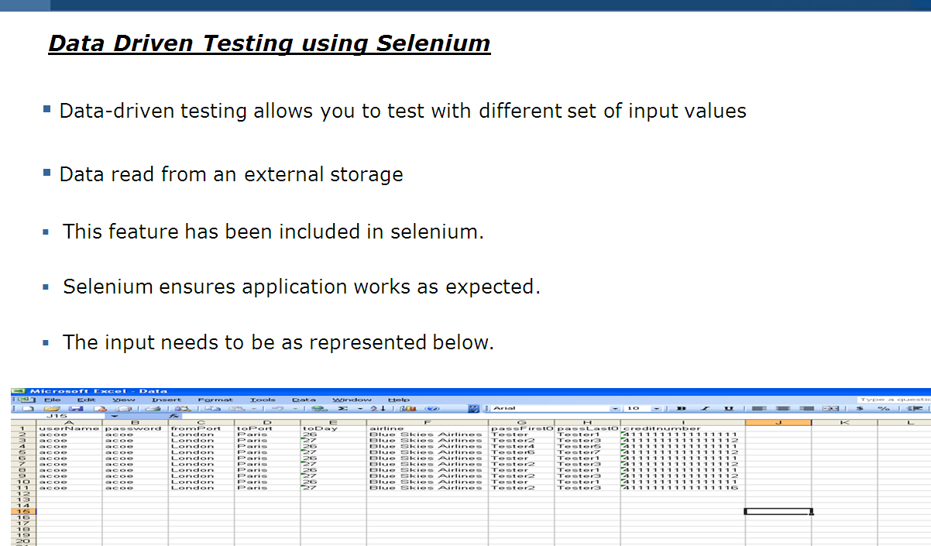

Report Generation
The captured results can be written to an HTML file and this allows the user to review the report generated after the data driven testing. To know how to use this feature, Please open the file “test” in the folder

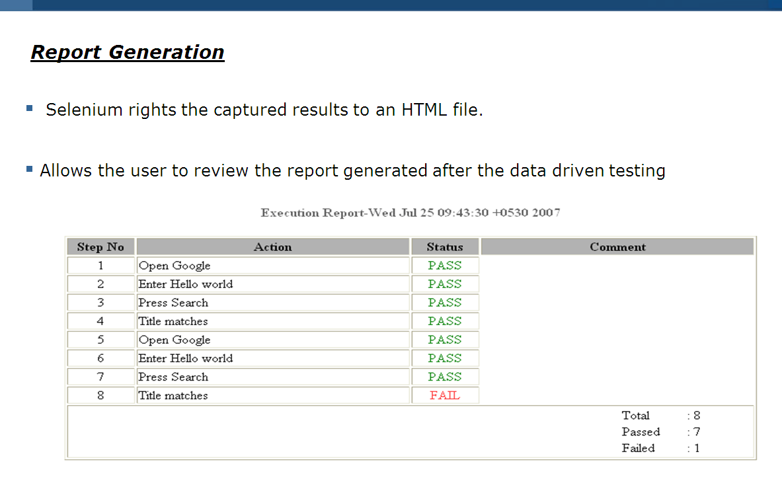

Chapter 5: Selenium Core

Selenium Core
Selenium Core is a test tool for web applications. Selenium Core tests run directly in a browser, just as real users do. And they run in Internet Explorer, Mozilla and Firefox on Windows, Linux, and Macintosh. No other test tool covers such a wide array of platforms.
- Browser compatibility testing. Test your application to see if it works correctly on different browsers and operating systems. The same script can run on any Selenium platform.
- System functional testing. Create regression tests to verify application functionality and user acceptance.
Selenium Core uses a unique mechanism which allows it to run on so many platforms. Written in pure JavaScript/DHTML, you copy Selenium Core tests directly into your application webserver, allowing the tests to run in any supported browser on the client-side. Thus, you must have write access to the machine your web application server is running on to install Selenium Core.
Selenium Core was developed by team of programmers and testers at ThoughtWorks. It is open-source software and can be downloaded and used without charge. It is currently under active development by our team. Stay tuned for updates and further announcements.
ThoughtWorks is a leader in Agile development methods for enterprise software development. Selenium is designed specifically for the acceptance testing requirements of Agile teams. However, teams using more traditional development will also find it useful.

How does Selenium Core Work?
Selenium uses JavaScript and iframes to embed a test automation engine in your browser. This technique should work with any JavaScript-enabled browser. Because different browsers handle JavaScript somewhat differently, we usually have to tweak the engine to support a wide range of browsers on Windows, Mac OS X and Linux.

Platform and Browser Compatibility
Supported Platforms:
- Windows:
  - Internet Explorer 6.0 and 7.0
  - Firefox 0.8 to 2.0
  - Mozilla Suite 1.6+, 1.7+
  - Seamonkey 1.0
  - Opera 8 & 9
- Mac OS X:
  - Safari 2.0.4+
  - Firefox 0.8 to 2.0
  - Camino 1.0a1
  - Mozilla Suite 1.6+, 1.7+
  - Seamonkey 1.0
Not yet supported: OmniWeb
- Linux:
  - Firefox 0.8 to 2.0
  - Mozilla Suite 1.6+, 1.7+
  - Konqueror
  - Opera 8 & 9

Installing Selenium Core
To use Selenium Core, you need to make it available from the same web server as the application you want to test. That means that you can't use Selenium Core (pure DHTML/JavaScript) to write a test of google.com. This is because Selenium Core is pure DHTML/JavaScript, and so it is bound by JavaScript's security restrictions. Specifically, JavaScript enforces (This is a JavaScript security requirement. If you can't/won't modify the webserver you want to test, Selenium Core may not be the right tool for you; you may just want to use Selenium IDE or Selenium RC instead. If you're on Windows and you only want to use Selenium Core with Internet Explorer, you may also use HTA mode to run your tests against a remote web site.)
Normally, this is as simple as extracting the Selenium Core zip file into the DocumentRoot, htdocs, or webroot of your webserver. Then, try to open the TestRunner.html page on your website, which should be in the core/ directory.
Download Selenium Core from the following link.
http://selenium-core.openqa.org/download.jsp

Running Selenium's Test Suite – Test Runner
TestRunner.html should look something like this:
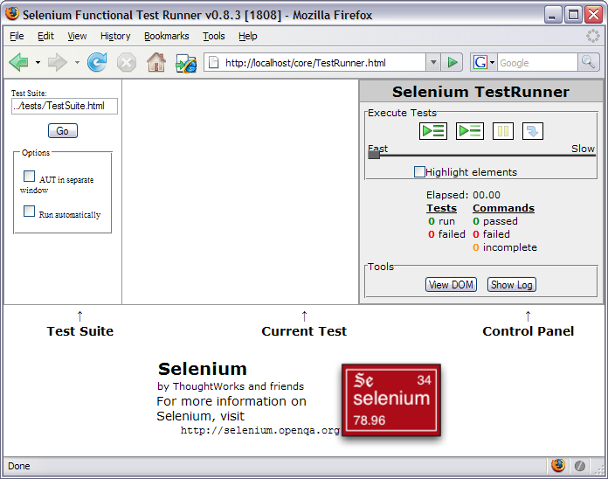
The screen is divided into four sections: "Test Suite", "Current Test", "Control Panel" and the main application frame where your application will reside. Initially, none of the Control Panel buttons will work, because you haven't selected a test suite. By default, Selenium Core offers to run the test suite in "../tests/TestSuite.html". Click "Go" to open that test suite.
If you installed the /tests along with /core, you should now see a list of tests to run. Press the "Run All Tests" button to run all of our automated tests. Note that some tests may fail if your browser blocks pop-ups, manages passwords, or does other helpful things that interfere with automation. Be sure to turn these features off before running the tests!

Control Panel
Here's a close-up view of the Selenium Control Panel:
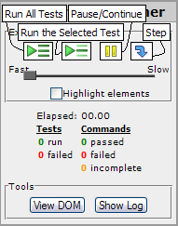
The four execution buttons on the top are:
- Run All Tests: Run every test in the test suite.
- Run Selected Test: Click on one test in the test suite, then click here to run just that one test.
- Pause / Continue: While a test is running, press the Pause button to temporarily stop running commands. After you press Pause, you can press Continue to resume the test.
- Step: Click on a test in the test suite, then click on just one line of the test to set a "breakpoint." When the Test Runner reaches a breakpoint, it will automatically pause execution on that line. You may then press the Step button to run the next line of the test and pause again. You can also click on a breakpoint line to remove the breakpoint.
Beneath the four execution buttons is the Speed Slider. You can drag the slider shuttle to the right to introduce artificial delays in your test, running your test more slowly than it would in a normal automated run. By default, Selenium will run your tests without any delay.
You may also check the "Highlight Elements" button to highlight elements as they are used in a Selenium test; each element will flash yellow as it is used. (Also be sure to check out the "highlight" command, which highlights just one element directly.)
The Control Panel lists out a summary of how long the tests have taken in aggregate, and a list of how many tests have passed/failed. Commands which were unable to execute due to errors are marked as "incomplete"; tests containing any failed or incomplete commands are considered failures.
"View DOM" provides a structured view of the DOM of your document as it's currently represented in the page, including any dynamically generated elements. It's fairly crude; you may prefer to use the Firefox DOM Explorer or IE Developer Toolbar for more sophisticated DOM analysis.
"Show Log" makes the log window appear; logging only occurs while the log window is open. Close the log window to stop logging.

Chapter 6: Selenium Grid

What is Selenium Grid?
Selenium Grid transparently distributes your tests on multiple machines so that you can run your tests in parallel, cutting down the time required for running acceptance tests to a fraction of the total time it currently takes. This will dramatically speed up in-browser web testing, giving you quick and accurate feedback you can rely on to improve your web application.

Selenium Grid is a tool that dramatically speeds up functional testing of web-apps by leveraging your existing computing infrastructure. It allows you to easily run multiple tests in parallel, on multiple machines, in a heterogeneous environment.
Based on the excellent Selenium web testing tool, Selenium Grid allows you to run multiple instances of Selenium Remote Control in parallel. Even better, it makes all these Selenium Remote Controls appear as a single one, so your tests do not have to worry about the actual infrastructure. Selenium Grid cuts down on the time required to run a Selenium test suite to a fraction of the time that a single instance of Selenium instance would take to run.
Of course, you get to choose which language you develop your tests in: Ruby, Java, Python, C#, PHP.

Click here to download Selenium Grid
http://selenium-grid.openqa.org/download.html

Why use Selenium Grid?
Below are some of the limitations of using Remote Control, thus forcing us to use Selenium Grid
- The Selenium remote control is quite slow at driving the browser. Therefore, unless your application or your network is especially slow, the remote control/browser pair will end up being the bottleneck of your test suite.
- You can only run a limited number of concurrent tests on the same remote control before seriously impacting its stability. Practically speaking, launching more than 6 browsers on the same Selenium Remote Control is not advisable. The limitations are even more drastic for Internet Explorer.
- Your tests can target multiple Selenium Remote Controls to work around the limitation on the number of parallel tests that you can run on a single remote control. Nevertheless that does not scale very well. It can easily be done at the continuous integration build level (one for Internet Explorer, one for Firefox, one for Safari). However, allocating a Selenium Remote Control to a specific test quickly becomes a nightmare if you want to run your selenium tests in a highly parallelized fashion. Your tests also become way too aware of the Selenium Remote Control infrastructure, which makes it difficult to evolve your infrastructure transparently.
Due to all these limitations, Selenium tests typically run in sequence or are only mildly parallelized. That makes for test suites that take from half an hour to multiple hours to run. Not ideal, especially if you strive for Agile processes emphasizing a quick feedback loop.

Selenium Grid Setup
Selenium Grid builds on the traditional Selenium setup, taking advantage of the following properties:
- The Selenium test, the application under test and the remote control/browser pair do not have to be co-located. They communicate through HTTP, so they can all live on different machines.
- The Selenium tests and the web application under test are obviously specific to a particular project. Nevertheless, neither the Selenium remote control nor the browser is tied to a specific application. As a matter of fact, they provide a capacity that can easily be shared by multiple applications and multiple projects.
- Consequently, if only we could build a distributed grid of Selenium Remote Controls, we could easily share it across builds, applications, projects - even potentially across organizations. Of course we would also need to address the scalability issues as described earlier when covering the traditional Selenium setup. This is why we need a component in charge of:
- Allocating a Selenium Remote Control to a specific test (transparently)
- Limiting the number of concurrent test runs on each Remote Control
- Shielding the tests from the actual grid infrastructure
- Selenium Grid calls this component the Selenium Hub.
- The Hub exposes an external interface that is exactly the same as the one of a traditional Remote Control. This means that a test suite can transparently target a regular Remote Control or a Selenium Hub with no code change. It just needs to target a different IP address. This is important as it shields the tests from the grid infrastructure (which you can scale transparently). This also makes the developer’s life easier. The same test can be run locally on a developer machine, or run on a heavy duty distributed grid as part of a build – without ever changing a line of code.
- The Hub allocates Selenium Remote Controls to each test. The Hub is also in charge of routing the Selenese requests from the tests to the appropriate Remote Control as well as keeping track of testing sessions.
- When a new test starts, the Hub puts its first request on hold if there is no available Remote Control in the grid providing the appropriate capabilities. As soon as a suitable Remote Control becomes available, the Hub will serve the request. For the whole time, the tests do not have to be aware of what is happening within the grid; it is just waiting for an HTTP response to come back.

Chapter 7: Selenium API

Selenium Concepts
A command is what tells Selenium what to do. Selenium commands come in three 'flavors': Actions, Accessors and Assertions. Each command call is one line in the test table of the form:
command | target | value
Actions are commands that generally manipulate the state of the application. They do things like "click this link" and "select that option". If an Action fails, or has an error, the execution of the current test is stopped.
Many Actions can be called with the "AndWait" suffix, e.g. "clickAndWait". This suffix tells Selenium that the action will cause the browser to make a call to the server, and that Selenium should wait for a new page to load.
Accessors examine the state of the application and store the results in variables, e.g. "storeTitle". They are also used to automatically generate Assertions.
Assertions are like Accessors, but they verify that the state of the application conforms to what is expected. Examples include "make sure the page title is X" and "verify that this checkbox is checked".
All Selenium Assertions can be used in 3 modes: "assert", "verify", and "waitFor". For example, you can "assertText", "verifyText" and "waitForText". When an "assert" fails, the test is aborted. When a "verify" fails, the test will continue execution, logging the failure. This allows a single "assert" to ensure that the application is on the correct page, followed by a bunch of "verify" assertions to test form field values, labels, etc.
"waitFor" commands wait for some condition to become true (which can be useful for testing Ajax applications). They will succeed immediately if the condition is already true. However, they will fail and halt the test if the condition does not become true within the current timeout setting (see the setTimeout action below).
Element Locators tell Selenium which HTML element a command refers to. Many commands require an Element Locator as the "target" attribute. Examples of Element Locators include "elementId" and "document.forms[0].element". These are described more clearly in the next section.
Patterns are used for various reasons, e.g. to specify the expected value of an input field, or identify a select option. Selenium supports various types of pattern, including regular-expressions, all of which are described in more detail below.
Defines an object that runs Selenium commands.

Click here for Element Locator
Click here for Selenium Actions
Click here for Selenium Accessors

Selenium Tips and Tricks

- Assert vs. verify: If you use selenium’s "verify" command - then the test suite/case - will still run - and fail at the end. Hence in most cases you should use "assert" command which will cause the test to stop.
- If web site does not allow itself to be frameable then use -multiwidow option(instead of -interactive) with Selenium RC.
- To eliminate certificate warning(and work cross domains ) use chrome/iehta modes:
http://selenium-rc.openqa.org/experimental.html
- Selenium has this cool - captureEntirePageScreenShot command which works
well with IDE/HTML. Consider using it at critical points (to debug
issues, if you schedule your test cases).
But with "programming" language like java - it may not work (try
using the "experimental" - capture Screenshot .
- Consider writing a wrapper for your Test Case/Test Suite in .net/jsp
so that you can maintain your test case/test suite in "HTML".
- If the recording is not working - then go to firefox and click on "Tools->Add on -> Selenium IDE " .First disable it and then enable it and restart the browser.
- Sometimes the browsers may not get killed after the test is run. So you may need to manually
kill it.
- When your "client" java test (using RC) finishes with error - then it does not give clear error -
you just the line number of the failed assert in stack trace - Hence you may need to trap all exceptions and print the "last body test"
- You may need to use lots of xpath in your test and firebug allows you to get xpath
by right clicking on the element.
- Sometimes selenium IDE may use "click" instead of "clickAndWait" for some
"submit" button cases resulting in your next page's assert/verify to fail. Hence
you should change it manually or add waitForPageToLoad with some timeout.

Chapter 8: Reference

Websites

http://selenium.openqa.org/
http://selenium-core.openqa.org/reference.html
http://selenium-grid.openqa.org/how_it_works.html
http://www.testearly.com/resources/selenium-ant/full-functional_viewlet_swf.html

